**“Music Streaming & Discovery Website”**

Internet Programming Laboratory – CSE326

**PROJECT REPORT**



**Submitted By:** **Submitted To:**

Aditya (12324327) Er. Nidhi Arora

Sharanjit (12302650) (Asst. Professor)

Shubham (12311506)

in partial fulfillment for the requirement of the award of degree of B. Tech. (Computer Science and Engineering)

LOVELY PROFESSIONAL UNIVERSITY

Phagwara, Punjab

Group Members:

1. Name: Aditya Arora

Roll No: 23

Registration No.: 12324327

1. Name: Sharanjit Singh

Roll No: 24

Registration No.: 12302650

1. Name: Shubham Pandey

Roll No: 25

Registration No.: 12311506

Table of Contents

Chapter Particulars Page No.

Chapter 1. Acknowledgement…………………………………………………………..3

Chapter 2. Introduction…………………………………………………………………4

Chapter 3. Technologies used.………………………………………………………….5

Chapter 4. Modules and Descriptions…………………………………………………6-43

Chapter 5. Website snapshots………………………………………….……………..44-54

References…………………………………………………………………….……………55

ACKNOWLEDGEMENT

Special thanks to our university as well as our mentor and CSE faculty, Nidhi Arora Ma’am for providing us the guidance and knowledge about the subject, which played a pivotal role in shaping the direction of our website and was instrumental in refining our ideas & improving the overall quality of the work.

We would like to express our heartfelt gratitude to everyone else as well who contributed to the development of “**melodies: music that moves you**”, a music streaming & discovery website project. This endeavour was a collaborative effort, and we are sincerely thankful for the support and assistance we received throughout it.

Thank you to everyone, group members and friends, who played a part, big or small, in completion of this project in the stipulated amount of time. The support is deeply appreciated.

Aditya Arora

Sharanjit Singh

Shubham Pandey

Introduction:

“***melodies: music that moves you***” is a music streaming and discovery website that we were assigned to make for our project in Internet Programming Laboratory. The need for a music streaming website arises from the desire to create a space where users can seamlessly immerse themselves in the world of music, discover new artists, and explore personalized playlists tailored to their tastes.

The demand for an accessible, versatile, and engaging platform for music consumption has never been more pressing. Traditional modes of acquiring and enjoying music have given way to the convenience of music streaming, allowing users to explore an extensive but selected catalogue of songs with just a few clicks, for now and users now seek platforms that offer convenience, an extensive music catalogue, and personalized discovery features.

While the project does not achieve all the above-mentioned tasks, it’s on its way to achieve so. We plan on keeping the website dynamic by making changes and improvements along the way as we learn more and more about web development and its front-end and back-end aspects.

By leveraging the power of HTML, CSS and JavaScript, the foundational building blocks of web development, Melodies was crafted to offer an intuitive and visually appealing interface that enhances the overall user experience.

Technologies Used:

Through the implementation of HTML, we were able to organize and present the various elements of the website, ensuring a logical and user-friendly layout. Whether it's the seamless navigation between pages, the display of selected artists’ profiles, or the presentation of curated playlists, HTML formed the backbone that brought structure and coherence to the platform.

CSS, the style sheet language, breathed life into Melodies by dictating its aesthetic appeal. With CSS, we meticulously designed the visual elements, ensuring a harmonious blend of colour schemes, typography, and responsive layouts. The use of CSS not only enhanced the website's visual appeal but also contributed to a consistent and enjoyable user interface across different devices.

While developing this music streaming and discovery website project, we incorporated JavaScript to enhance specific functionalities, albeit in a minimal capacity. JavaScript was strategically employed to serve targeted purposes, such as facilitating dynamic content updates and improving user interactivity. While JavaScript does add valuable interactive elements, its role is supplementary, with the primary emphasis placed on harnessing the capabilities of HTML and CSS to create a cohesive and engaging music streaming platform.

‘melodies’, with the usage of website building technologies, exceeds expectations by providing a visually captivating and user-friendly environment for music enthusiasts to explore, enjoy, and discover melodies that make them move.

Modules and Description:

The project consists of several webpages that allow the user to register on the website using their name, set password and then log in. It also allows the user to choose their favorite artists. The user can also go through selected playlists on the homepage of the website and explore selected songs to play. The user can also search artists and music and albums up in the Search Bar of the website.

Most of these tasks were accomplished using one of the major parts of HTML i.e. ‘Forms’. With their varied usage and properties in radio buttons, we were able to enable a tab-like display allowing user to see only one portion of content at a time.

Anchor tag <a> was majorly used to link the webpages to one another. The links have been highlighted, using a white text-decoration underline to allow easy navigation to the next webpage.

The star of the show, with no surprise, is <div> tag. Its seemingly endless CSS properties and usages in text, element, form arrangement makes it the contender of the most important tag. Being a block creating tag, it also allowed us to create easy sections in the website. In the home page of the main page, several <div>s have been used to specify and create divisions of elements and images and text blocks. So is the case in Discover Page and Archive Page.

Home page allows the user to explore several curated playlists and open selected ones of them- the “Desi-Pop Mix” with the playlist page opening and the first song “Aao Milon Chalein” being functional.

CSS properties for box models and flex have been used to enable shadow effects, as well as making an ordered way to present elements that need to be presented. In the Discover page, there exists an option to play the song “drivers license” and open an artist’s (Lana Del Rey’s) page. The user can also search in the search bar. This was undoubtedly achieved using Forms.

In the archive tab, it clearly shows 3 <div>s, which are podcasts, liked songs and my profile. The user can click on edit profile to update their profile picture by selecting it from their own local storage. It has been enabled so with the usage of JavaScript.

All in all, the website consists of 11 webpages with the three tabs- Home, Discover and Archive being considered separately.

While external CSS has been used for some webpages, internal CSS has been preferred to allow easy portability and better understanding of the code. It also allows convenient modification options.

Usage of varied type of selectors, including, but not limited to class, id, pseudo class and attribute has been done throughout the 11 webpages. Several fonts have been linked in the head section using the <link> tag, in every webpage to maintain a continuity and flow. ‘Work Sans’, a google font has been used to achieve aesthetic goals and ease of reading. Comments here and there have been provided for better understanding of the code.

Code for the First Page:

Get Started

<!DOCTYPE html>

<html>

<head>

<link href="https://fonts.googleapis.com/css2?family=Agbalumo&family=Courgette&family=Work+Sans:wght@300&display=swap" rel="stylesheet">

<link href="pg1.css" rel="stylesheet">

</head>

<body>

<div class="container">

<h1>melodies</h1>

<p>music that moves you</p>

<button class="button">

<a href="login_form1.html">Get Started</a>

</button>

</div>

</body>

</html>

pg1.css:

body {

background-image:url(pngg2.png);

background-size:cover;

text-align: center;

}

.container {

margin-top: 100px;

}

h1 {

font-family:Courgette;

color:rgb(253, 112, 61);

font-size: 80px;

margin-bottom: 5px;

}

p {

font-family:work sans;

font-size: 20px;

color:salmon;

font-weight:20px;

}

.button {

background-color:transparent;

color:white;

font-family:work sans;

padding: 15px 30px;

border: none;

font-weight:20px;

border-radius: 5px;

font-size: 18px;

cursor: pointer;

transition: background-color 0.3s;

}

a {

text-decoration: underline;

text-decoration-color:white;

}

a:visited{

text-decoration:none;

color:white;

}

.button : hover {

background-color:rgb(253, 112, 61);

}

Code for the Second Page:

Registration/Log-In Page

<!DOCTYPE html>

<html>

<head>

<title>Login!</title>

<link href="https://fonts.googleapis.com/css2?family=Agbalumo&family=Courgette&family=Work+Sans:wght@300&display=swap" rel="stylesheet">

<link href="pg2.css" rel="stylesheet">

</head>

<body>

<div class="container">

<h2>Sign up to begin your Musical Journey</h2>

<form id="username-form">

<input type="text" id="username" name="username" required placeholder="Pick a Username">

<input type="password" id="password" name="password" required placeholder="Enter password">

<input type="password" id="confirmPassword" name="confirmPassword" required placeholder="Confirm Password">

<input type="email" id="email" name="email" required placeholder="E-mail">

<button type="submit"><a href="hof_selection.html">Register</a></button>

</form>

</div>

<script>

// JavaScript to handle form submission

document.getElementById("username-form").addEventListener("submit", function(e) {

e.preventDefault(); // Prevent the form from actually submitting

const username = document.getElementById("username").value;

localStorage.setItem("username", username);

});

</script>

</body>

</html>

pg2.css:

body {

font-family: work sans, sans-serif;

background-image:url("pngh.png");

background-size:cover;

margin: 0;

padding: 0;

display: flex;

justify-content: center;

align-items: center;

height: 100vh;

}

.container {

background-color:rgba(224, 94, 34, 0.568);

padding: 20px;

border-radius: 5px;

box-shadow: 0 0 10px rgba(0, 0, 0, 0.1);

width: 300px;

}

h2 {

text-align: center;

color:white;

}

form {

display:flex;

height:270px;

width:300px;

flex-direction:column;

}

input {

margin: 10px 0;

}

input[type="text"], input[type="password"], input[type="email"] {

padding: 10px;

border: 1px solid #ccc;

border-radius: 3px;

outline: none;

}

button {

background-color:transparent;

color:black;

padding: 10px;

border: none;

border-radius: 3px;

cursor: pointer;

font-weight:bold;

font-family: work sans;

}

button:hover {

background-color:rgb(211, 79, 31);

}

input[placeholder]{

font-family: work sans;

color:rgb(211, 79, 31)}

a{

text-decoration: underline;

text-decoration-color:white;

color:white;

font-size:24px;

}

Code for the third page:

Select your favourite artist

<!DOCTYPE html>

<html lang="en">

<head>

<meta charset="UTF-8">

<meta name="viewport" content="width=device-width, initial-scale=1.0">

<title>Select Your Favorite Artists</title>

<link href="https://fonts.googleapis.com/css2?family=Agbalumo&family=Courgette&family=Work+Sans:wght@300&display=swap" rel="stylesheet"/>

<link href="pg3.css" rel="stylesheet">

</head>

<body>

<div class="container">

<h2>Select Your Favorite Artists</h2>

<ul class="artist-list">

<li class="artist-item">

<input type="checkbox" id="artist1">

<label for="artist1">

<img src="sn.jpg" alt="Artist 1" class="artist-img">

<p>Sonu Nigam</p>

</label>

</li>

<!-- Add more artist items as needed -->

<li class="artist-item">

<input type="checkbox" id="artist2">

<label for="artist2">

<img src="mc.jpg" alt="Artist 2" class="artist-img">

<p>Mohit Chauhan</p>

</label>

</li>

<li class="artist-item">

<input type="checkbox" id="artist3">

<label for="artist3">

<img src="lm.jpg" alt="Artist 3" class="artist-img">

<p>Lata Mangeshkar</p>

</label>

</li>

<li class="artist-item">

<input type="checkbox" id="artist4">

<label for="artist4">

<img src="mr.jpg" alt="Artist 4" class="artist-img">

<p>Mohammad Rafi</p>

</label>

</li>

<li class="artist-item">

<input type="checkbox" id="artist5">

<label for="artist5">

<img src="am.jpg" alt="Artist 5" class="artist-img">

<p>Armaan Malik</p>

</label>

</li>

<li class="artist-item">

<input type="checkbox" id="artist6">

<label for="artist6">

<img src="aj.jpg" alt="Artist 6" class="artist-img">

<p>Anuv Jain</p>

</label>

</li>

<li class="artist-item">

<input type="checkbox" id="artist7">

<label for="artist7">

<img src="pk.jpg" alt="Artist 7" class="artist-img">

<p>Prateek Kuhad</p>

</label>

</li>

<li class="artist-item">

<input type="checkbox" id="artist8">

<label for="artist8">

<img src="ab.jpg" alt="Artist 8" class="artist-img">

<p>Asha Bhosle</p>

</label>

</li>

<li class="artist-item">

<input type="checkbox" id="artist9">

<label for="artist9">

<img src="kk.jpg" alt="Artist 9" class="artist-img">

<p>Kishore Kumar</p>

</label>

</li>

<li class="artist-item">

<input type="checkbox" id="artist10">

<label for="artist10">

<img src="Shreya Ghoshal.jpg" alt="Artist 10" class="artist-img">

<p>Shreya Ghoshal</p>

</label>

</li>

<li class="artist-item">

<input type="checkbox" id="artist11">

<label for="artist11">

<img src="aa.jpg" alt="Artist 11" class="artist-img">

<p>Atif Aslam</p>

</label>

</li>

<li class="artist-item">

<input type="checkbox" id="artist12">

<label for="artist12">

<img src="Arijit Singh.jpg" alt="Artist 12" class="artist-img">

<p>Arijit Singh</p>

</label>

</li>

<li class="artist-item">

<input type="checkbox" id="artist13">

<label for="artist13">

<img src="mm.jpg" alt="Artist 13" class="artist-img">

<p>Karan Aujla</p>

</label>

</li>

<li class="artist-item">

<input type="checkbox" id="artist14">

<label for="artist14">

<img src="ct.jpg" alt="Artist 14" class="artist-img">

<p>King</p>

</label>

</li>

<li class="artist-item">

<input type="checkbox" id="artist15">

<label for="artist15">

<img src="kk1.jpg" alt="Artist 15" class="artist-img">

<p>KK</p>

</label>

</li>

<li class="artist-item">

<input type="checkbox" id="artist16">

<label for="artist16">

<img src="sza.jpg" alt="Artist 16" class="artist-img">

<p>SZA</p>

</label>

</li>

<li class="artist-item">

<input type="checkbox" id="artist17">

<label for="artist17">

<img src="ts.jpg" alt="Artist 17" class="artist-img">

<p>Taylor Swift</p>

</label>

</li>

<li class="artist-item">

<input type="checkbox" id="artist18">

<label for="artist18">

<img src="tw.jpg" alt="Artist 18" class="artist-img">

<p>The Weeknd</p>

</label>

</li>

<li class="artist-item">

<input type="checkbox" id="artist19">

<label for="artist19">

<img src="sg.jpg" alt="Artist 19" class="artist-img">

<p>Selena Gomez</p>

</label>

</li>

<li class="artist-item">

<input type="checkbox" id="artist20">

<label for="artist20">

<img src="jb.jpg" alt="Artist 20" class="artist-img">

<p>Justin Bieber</p>

</label>

</li>

</ul>

<button id="nextBtn"><a href="homearchive2.html">Next</a></button>

</div>

</body>

</html>

pg3.css:

body {

margin: 0;

padding: 0;

display: flex;

justify-content: center;

align-items: center;

color:white;

font-family:work sans;

background-color:rgb(26, 25, 25);

}

.container {

background-color:rgb(26, 25, 25);

padding: 20px;

border-radius: 8px;

box-shadow: 0 0 10px rgba(0, 0, 0, 0.1);

text-align: center;

}

.artist-list {

list-style: none;

padding: 0;

display: flex;

flex-wrap: wrap;

justify-content: center;

}

.artist-item {

margin: 10px;

text-align: center;

}

input[type="checkbox"] {

display: none;

}

label {

display: block;

cursor: pointer;

transition: transform 0.3s;

}

input[type="checkbox"]:checked + label {

transform: scale(1.1);

}

.artist-img {

max-width: 100px;

max-height: 100px;

border-radius: 50%;

margin-bottom: 5px; }

#nextBtn {

background-color:transparent;

color: #fff;

padding: 10px 20px;

font-size: 16px;

border: none;

border-radius: 5px;

cursor: pointer;

margin-top: 20px;

transition: background-color 0.3s;}

#nextBtn:hover {

background-color:rgb(211, 79, 31);}

a{

text-decoration:underline;

text-decoration-color: white;

color:white;

}

Code for the Fourth Page: (consisting of several other pages)

Home Page, Discover Page, Archive Page:

<!DOCTYPE html>

<html>

<head>

<link href="https://fonts.googleapis.com/css2?family=Agbalumo&family=Courgette&family=Work+Sans:wght@300&display=swap" rel="stylesheet"/>

<link rel="stylesheet" href="pg4.css">

</head>

<body>

<input type="radio" id="Home" name="tab" checked>

<input type="radio" id="Discover" name="tab">

<input type="radio" id="Archive" name="tab">

<label for="Home" class="tab"><img src="home.png" height="20" width="20"></label>

<label for="Discover" class="tab"><img src="discover.png" height="20" width="20"></label>

<label for="Archive" class="tab"><img src="archive.png" height="20" width="20"></label>

<div id="HomeContent" class="tab-content">

<script>

// JavaScript to retrieve and use the saved username

const savedUsername = localStorage.getItem("username");

if (savedUsername) {

document.write(`<h1>Welcome, ${savedUsername}!</h1>`);

} else {

document.write("<h1>Welcome!</h1>");

}

</script>

<fieldset>

<legend>Discover New</legend>

<div class="flex-container">

<div class="image">

<a href="playlist page.html"><img src="desi pop.jpg" alt="Image 5" id="abc" class="desipop"></a>

<span id="playlists">&nbsp;&nbsp;&nbsp;&nbsp;&nbsp;&nbsp;&nbsp;&nbsp;&nbsp;&nbsp;&nbsp;<a href="playlist page.html">Desi-Pop Mix</a></span>

</div>

<div class="image">

<img src="hip hop.jpg" alt="Image 1" id="abc">

<span id="playlists">&nbsp;&nbsp;&nbsp;&nbsp;&nbsp;&nbsp;&nbsp;&nbsp;&nbsp;&nbsp;&nbsp;&nbsp;Hip-Hop Mix</span>

</div>

<div class="image">

<img src="rnb.jpg" alt="Image 2" id="abc">

<span id="playlists">&nbsp;&nbsp;&nbsp;&nbsp;&nbsp;&nbsp;&nbsp;&nbsp;&nbsp;&nbsp;&nbsp;&nbsp;&nbsp;&nbsp;&nbsp;&nbsp;RnB Mix</span>

</div>

<div class="image">

<img src="jazz1.jpg" alt="Image 3" id="abc">

<span id="playlists">&nbsp;&nbsp;&nbsp;&nbsp;&nbsp;&nbsp;&nbsp;&nbsp;&nbsp;&nbsp;&nbsp;&nbsp;&nbsp;&nbsp;&nbsp;&nbsp;Jazz Mix</span>

</div>

<div class="image">

<img src="pop.jpg" alt="Image 4" id="abc">

<span id="playlists">&nbsp;&nbsp;&nbsp;&nbsp;&nbsp;&nbsp;&nbsp;&nbsp;&nbsp;&nbsp;&nbsp;&nbsp;&nbsp;&nbsp;&nbsp;&nbsp;Pop Mix</span>

</div>

</div>

</fieldset >

<br><br><br>

<fieldset class="albums">

<legend>Albums for you</legend>

<div class="flexx-cont"><div class="album">

<img src="mm.jpg" alt="Album 1 Image">

</div>

<div class="album">

<img src="utopia.jpg" alt="Album 1 Image">

</div>

<div class="album">

<img src="ct.jpg" alt="Album 1 Image">

</div>

<div class="album">

<img src="vc.jpg" alt="Album 2 Image">

</div>

<div class="album">

<img src="lem.jpg" alt="Album 3 Image">

</div>

<div class="album">

<img src="yjhd.jpg" alt="Album 3 Image">

</div>

<div class="album">

<img src="starboy.jpg" alt="Album 3 Image">

</div>

</div>

</fieldset>

<br><br><br>

<fieldset>

<legend>You might like</legend>

<div class="flex-container">

<div class="image">

<img src="autumn.jpg" alt="Image 1" id="abc">

<span id="playlists">&nbsp;&nbsp;&nbsp;&nbsp;&nbsp;&nbsp;&nbsp;&nbsp;&nbsp;&nbsp;Autumn Vibes</span>

</div>

<div class="image">

<img src="catchy.jpg" alt="Image 2" id="abc">

<span id="playlists">&nbsp;&nbsp;&nbsp;&nbsp;&nbsp;&nbsp;&nbsp;&nbsp;&nbsp;&nbsp;&nbsp;&nbsp;&nbsp;Catchy Hits</span>

</div>

<div class="image">

<img src="alt.jpg" alt="Image 3" id="abc">

<span id="playlists">&nbsp;&nbsp;&nbsp;&nbsp;&nbsp;&nbsp;&nbsp;&nbsp;&nbsp;&nbsp;&nbsp;&nbsp;&nbsp;&nbsp;&nbsp;&nbsp;Alt Mix</span>

</div>

<div class="image">

<img src="classical.jpg" alt="Image 4" id="abc">

<span id="playlists">&nbsp;&nbsp;&nbsp;&nbsp;&nbsp;&nbsp;&nbsp;&nbsp;&nbsp;&nbsp;&nbsp;&nbsp;Classical Hits</span>

</div>

<div class="image">

<img src="euphoria.jpg" alt="Image 5" id="abc">

<span id="playlists">&nbsp;&nbsp;&nbsp;&nbsp;&nbsp;&nbsp;&nbsp;&nbsp;&nbsp;&nbsp;&nbsp;&nbsp;Euphoria Feels</span>

</div>

</div>

</fieldset >

<br><br><br>

<fieldset>

<legend>Popular Now</legend>

<div class="flex-container">

<div class="image">

<img src="thank u next.jpg" alt="Image 1" id="abc">

<span id="playlists">&nbsp;&nbsp;&nbsp;&nbsp;&nbsp;&nbsp;&nbsp;&nbsp;&nbsp;&nbsp;&nbsp;&nbsp;thank u, next</span>

</div>

<div class="image">

<img src="surfer dude.jpg" alt="Image 2" id="abc">

<span id="playlists">&nbsp;&nbsp;&nbsp;&nbsp;&nbsp;&nbsp;&nbsp;&nbsp;&nbsp;&nbsp;&nbsp;&nbsp;&nbsp;&nbsp;&nbsp;&nbsp;Beachy Vibes</span>

</div>

<div class="image">

<img src="carefree.jpg" alt="Image 3" id="abc">

<span id="playlists">&nbsp;&nbsp;&nbsp;&nbsp;&nbsp;&nbsp;&nbsp;&nbsp;&nbsp;&nbsp;&nbsp;&nbsp;&nbsp;&nbsp;&nbsp;&nbsp;Carefree Mix</span>

</div>

<div class="image">

<img src="night drives.jpg" alt="Image 4" id="abc">

<span id="playlists">&nbsp;&nbsp;&nbsp;&nbsp;&nbsp;&nbsp;&nbsp;&nbsp;&nbsp;&nbsp;&nbsp;Late Night Drive Mix</span>

</div>

<div class="image">

<img src="limelight.jpg" alt="Image 5" id="abc">

<span id="playlists">&nbsp;&nbsp;&nbsp;&nbsp;&nbsp;&nbsp;&nbsp;&nbsp;&nbsp;&nbsp;&nbsp;Streetlights Mix</span>

</div>

</div>

</fieldset >

<br><br><br>

</div>

<div id="DiscoverContent" class="tab-content">

<form id="username-form">

<div class="search-container">

<input type="text" class="search-input" placeholder="Search..." class="search-input">

</div>

<form>

<br><br><br>

<fieldset>

<legend>Popular Searches</legend><br>

<div class="player-container">

<img class="player-image" src="ldr.jpg" alt="Player Image">

<div class="player-info">

<div class="player-name"><a href="artist_page3.html">Lana Del Rey</a></div>

</div>

<a href="artist_page3.html"><button class="play-button">&#9654;</button></a>

</div>

<br>

<div class="player-container">

<img class="player-image" src="ts.jpg" alt="Player Image">

<div class="player-info">

<div class="player-name">Taylor Swift</div>

</div>

<button class="play-button">&#9654;</button>

</div>

<br>

<div class="player-container">

<img class="player-image" src="Shreya Ghoshal.jpg" alt="Player Image">

<div class="player-info">

<div class="player-name">Shreya Ghoshal</div>

</div>

<button class="play-button">&#9654;</button>

</div>

<br>

<div class="player-container">

<img class="player-image" src="olivia.jpg" alt="Player Image">

<div class="player-info">

<div class="player-name"><a href="dl.html">Drivers License</a><span id="abc"> - Olivia Rodrigo</span></div>

</div>

<button class="play-button">&#9654;</button>

</div>

<br>

<div class="player-container">

<img class="player-image" src="Arijit Singh.jpg" alt="Player Image">

<div class="player-info">

<div class="player-name">Arijit Singh</div>

</div>

<button class="play-button">&#9654;</button>

</div><br>

</fieldset>

</div>

<div id="ArchiveContent" class="tab-content">

<div class="containeradf">

<div class="sectionadf">

<h2 id="fgh">Your Podcasts</h2>

<div class="podcast-content">

<div class="podcast">

<img id="podcastimg" src="omitb.jpg" alt="Podcast 1">

<p>Only Murders in the Building</p>

</div>

<div class="podcast">

<img id="podcastimg" src="dark house.jpg" alt="Podcast 2">

<p>Dark House</p>

</div>

</div>

</div>

<div class="sectionadf">

<h2 id="fgh">Your Profile</h2>

<div class="profile-content">

<img id="profile-pic" src="anon.jpg" alt="Your Profile">

<p><a href="edit12.html">EDIT PROFILE</a></p>

<p>New User - Joined Recently</p>

</div>

</div>

</div>

<div class="liked-songs">

<h2 id="fgh">Liked Songs</h2>

<div class="player-container">

<img class="player-image" src="haareya.jpg" alt="Player Image">

<div class="player-info">

<div class="player-name">Haareya</div>

</div>

<button class="play-button">&#9654;</button>

</div>

<br>

<div class="player-container">

<img class="player-image" src="khudajaane.jpg" alt="Player Image">

<div class="player-info">

<div class="player-name">Khuda Jaane</div>

</div>

<button class="play-button">&#9654;</button>

</div>

<br>

<div class="player-container">

<img class="player-image" src="jeb.jpg" alt="Player Image">

<div class="player-info">

<div class="player-name">Jashn-e-Bahara</div>

</div>

<button class="play-button">&#9654;</button>

</div>

<br>

<div class="player-container">

<img class="player-image" src="kkp.jpg" alt="Player Image">

<div class="player-info">

<div class="player-name">Khaabon ke Parindey</div>

</div>

<button class="play-button">&#9654;</button>

</div>

<br>

</div>

</div>

</body>

</html>

pg4.css:

*{font-family:work sans;color:white;}

body{background-color:rgb(26, 25, 25);}

h1{color:white;font-family:work sans;font-weight:bold;}

legend{

color:white;

font-family:work sans;

}

.tab {

display: inline-block;

padding:10 px 33.3px;

background-color: rgb(26, 25, 25);

color: #fff;

border: none;

cursor: pointer;

font-size: 16px;

width:25%;

}

.tab:hover {

background-color: rgb(22, 20, 20);

}

.tab-content {

display: none;

padding: 20px;

}

#Home:checked ~ #HomeContent,

#Discover:checked ~ #DiscoverContent,

#Archive:checked ~ #ArchiveContent {

display: block;

}

input[type="radio"] {

display: none;

}

label {

display: inline-block;

margin: 0 5px;

padding: 10px 20px;

background-color: #0074d9;

color: #fff;

cursor: pointer;

font-size: 16px;

}

.flex-container {

display: flex;

justify-content: space-between;

align-items: center;

width: 100%;

}

.image {

width: 20%;

padding: 10px;

box-sizing: border-box;

}

.image img {

width: 30vh;

height: auto;

}

#playlists{

color:white;

text-align:center;

font-family:work sans;

}

.search-container{

background-color:rgb(26, 25, 25);

padding: 20px;

border-radius: 5px;

box-shadow: 0 0 5px white;

width: 97.5%;

}

.search-input {

width: 97.5%;

padding: 10px;

border: 1px solid #ccc;

border-radius: 5px;

outline: none;

background-color:rgb(26, 25, 25);

color:white;}

#abc{

border-radius: 10%;

overflow: hidden;

}

.player-container {

display: flex;

align-items: center;

width: 97.5%;

background-color: rgb(26, 25, 25);

border-radius: 15px;

padding: 10px;

box-shadow: 0.5px 0.5px 0.5px 1px white;

}

.player-image {

width: 50px;

height: 50px;

border-radius: 50%;

margin-right: 10px;

}

.player-info {

flex: 1;

}

.player-name {

font-weight: bold;

font-size: 18px;

color:white;

font-family:work sans;

}

.play-button {

background-color: rgb(211, 79, 31);

color: rgb(26, 25, 25);

border: none;

border-radius: 50%;

width: 40px;

height: 40px;

font-size: 20px;

cursor: pointer;

}

#abc{

font-family:work sans;

font-size:12px;

color:rgba(258,258,258,0.7)

}

a {

text-decoration:underline;

text-decoration-color:white;

color:white;

}

.containeradf {

display: flex;

justify-content: space-between;

padding: 20px;

}

.sectionadf {

flex: 1;

border: 1px solid #ccc;

padding: 20px;

}

#fgh {

text-align: center;

}

.podcast-content, .profile-content {text-align: center;}

.podcast {margin: 20px;}

#podcastimg {max-width: 100%;height:100px;width:100px;}

#profile-pic{border-radius:50%;max-width: 100%;height:100px;width:100px;}

.liked-songs {text-align: center;margin: 20px;}

.albums {margin-top: 20px;border: 1px solid #ccc;padding: 20px;}

.album {margin-right: 20px;}

.album img {width: 150px;height: 150px;object-fit: cover;}

.flexx-cont {display: flex;justify-content: space-between;align-items: center;width: 100%;}

.desipop{box-shadow: 1px 1px 3px white;}

Code for Page 7:

Playlist Page

<!DOCTYPE html>

<html>

<head>

<link href="https://fonts.googleapis.com/css2?family=Agbalumo&family=Courgette&family=Work+Sans:wght@300&display=swap" rel="stylesheet">

<style>

*{

font-family:work sans;

}

body {

font-family: Arial, sans-serif;

background-color: rgb(26, 25, 25);

text-align: center;

}

.playlist {

display:block;

align-items: center;

background-color: rgb(26, 25, 25);

border: 1px solid #ddd;

margin: 20px;

padding: 10px;

border-radius: 5px;

box-shadow: 0 2px 4px rgba(0, 0, 0, 0.1);

}

.playlist-cover {

flex: 1;

max-width: 150px;

padding: 10px;

}

.playlist-cover img {

max-width: 100%;

border-radius: 5px;

}

.playlist-info {

flex: 3;

text-align: left;

padding: 10px;

}

h2 {

font-size: 24px;

margin: 0;

color:white;

}

p {

font-size: 16px;

margin: 0;

color: #666;

color:white;

}

.player-container {

display: flex;

align-items: center;

width: 95%;

background-color: rgb(26, 25, 25);

border-radius: 15px;

padding: 10px;

box-shadow: 0.5px 0.5px 0.5px 1px white;

}

.player-image {

width: 50px;

height: 50px;

border-radius: 50%;

margin-right: 10px;

}

.player-info {

flex: 1;

}

.player-name {

font-weight: bold;

font-size: 18px;

color:white

}

.play-button {

background-color: rgb(211, 79, 31);

color: rgb(26, 25, 25);

border: none;

border-radius: 50%;

width: 40px;

height: 40px;

font-size: 20px;

cursor: pointer;

}

a{

text-decoration:underline;

text-decoration-color:white;

color:white;

}

</style>

</head>

<body>

<div class="playlist">

<div class="playlist-cover">

<img src="desi pop.jpg" alt="Playlist Cover">

</div>

<div class="playlist-info">

<h2>Desi-Pop Mix</h2>

<p>45 min</p>

</div>

<div class="player-container">

<img class="player-image" src="aaon milo chalein.jpg" alt="Player Image">

<div class="player-info">

<div class="player-name"><a href="amc.html">Aaon Milo Chalein</a></div>

</div>

<button class="play-button">&#9654;</button>

</div>

<br>

<div class="player-container">

<img class="player-image" src="matargashti.jpg" alt="Player Image">

<div class="player-info">

<div class="player-name">Matargashti</div>

</div>

<button class="play-button">&#9654;</button>

</div>

<br>

<div class="player-container">

<img class="player-image" src="sun raha hai na tu.jpg" alt="Player Image">

<div class="player-info">

<div class="player-name">Sun raha hai na tu</div>

</div>

<button class="play-button">&#9654;</button></div><br>

<div class="player-container">

<img class="player-image" src="laal ishq.jpg" alt="Player Image">

<div class="player-info">

<div class="player-name">Laal Ishq</div>

</div>

<button class="play-button">&#9654;</button>

</div>

<br>

<div class="player-container">

<img class="player-image" src="jab saiyaan.jpg" alt="Player Image">

<div class="player-info">

<div class="player-name">Jab Saiyaan</div>

</div>

<button class="play-button">&#9654;</button>

</div>

<br>

<div class="player-container">

<img class="player-image" src="tu hi hai.jpg" alt="Player Image">

<div class="player-info">

<div class="player-name">Tu Hi Hai</div>

</div>

<button class="play-button">&#9654;</button></div><br>

<div class="player-container">

<img class="player-image" src="first class.jpg" alt="Player Image">

<div class="player-info">

<div class="player-name">First Class</div>

</div>

<button class="play-button">&#9654;</button> </div><br>

<div class="player-container">

<img class="player-image" src="dil ka pata.jpg" alt="Player Image">

<div class="player-info">

<div class="player-name">Dil Ka Pata</div>

</div>

<button class="play-button">&#9654;</button></div>

</div>

</div>

</body>

</html>

Code for page 8:

Song Page 1:

<!DOCTYPE html>

<html lang="en">

<head>

<link href="https://fonts.googleapis.com/css2?family=Agbalumo&family=Courgette&family=Work+Sans:wght@300&display=swap" rel="stylesheet"/>

<meta charset="UTF-8">

<meta name="viewport" content="width=device-width, initial-scale=1.0">

<title>Spotify-like Music Player</title>

<style>

*{

font-family: work sans;

color:white;

}

body {

font-family: Arial, sans-serif;

background-color: rgb(26,26,26);

color: #fff;

display: flex;

flex-direction: column;

align-items: center;

justify-content: center;

height: 100vh;

margin: 0;

}

.music-player123 {

background: rgba(135, 207, 235, 0.507);

border-radius: 8px;

width: 300px;

padding: 20px;

display: flex;

flex-direction: column;

align-items: center;

text-align: center;

}

.cover-image {

width: 200px;

height: 200px;

border-radius: 8px;

object-fit: cover;

}

.song-info1 {

margin-top: 20px;

}

.song-title1 {

font-size: 18px;

font-weight: bold;

}

.artist-names {

margin-top: 5px;

font-size: 14px;

color:rgba(255, 255, 255, 0.897);

}

.controlsabc {

margin-top: 20px;

}

</style>

</head>

<body>

<div class="music-player123">

<img class="cover-image" src="aaon milo chalein.jpg" alt="Album Cover">

<div class="song-info1">

<div class="song-title1">Aao Milo Chalein</div>

<div class="artist-names">Shaan</div>

</div>

<br><br>

<audio controls>

<source src="aaon milo chalein.mp3" type="audio/mpeg">

</audio>

</div>

</div>

</body>

</html>

Code for Page 9:

Artist Page:

<!DOCTYPE html>

<html lang="en">

<head>

<meta charset="UTF-8">

<meta name="viewport" content="width=device-width, initial-scale=1.0">

<link href="https://fonts.googleapis.com/css2?family=Agbalumo&family=Courgette&family=Work+Sans:wght@300&display=swap" rel="stylesheet">

<title>Artist Page</title>

<style>

* {

margin: 0;

padding: 0;

box-sizing: border-box;

font-family:work sans;

}

.flexx-cont {

display: flex;

justify-content: space-between;

align-items: center;

width: 100%;}

body {

font-family: Arial, sans-serif;

background-color: rgb(26, 25, 25);

color:white;

}

.container {

display: flex;

}

.image-container {

width: 33%;

height: 100vh;

overflow: hidden;

}

.image-container img {

width: 100%;

height: 100%;

object-fit: cover;

}

.info-container {

width: 67%;

padding: 20px;

text-align: center;

display: flex;

flex-direction: column;

justify-content: center;

align-items: center;

}

h1 {

font-size: 36px;

margin-bottom: 20px;

}

.popular-songs {

display: flex;

flex-direction: column;

align-items: center;

gap: 20px;

}

.song {

display: flex;

align-items: center;

}

.song img {

width: 100px;

height: 100px;

object-fit: cover;

border: 1px solid #ccc;

}

.song p {

margin: 0 20px;

font-weight: bold;

}

.like-button {

background-color: #3498db;

color: #fff;

border: none;

padding: 5px 10px;

border-radius: 5px;

cursor: pointer;

}

.albums {

margin-top: 20px;

border: 1px solid #ccc;

padding: 20px;

}

.album {

margin-right: 20px;

}

.album img {

width: 150px;

height: 150px;

object-fit: cover;

}

#abc{

border-radius: 10%;

overflow: hidden;

}

.player-container {

display: flex;

align-items: center;

width: 97.5%;

background-color: rgb(26, 25, 25);

border-radius: 15px;

padding: 10px;

box-shadow: 0.5px 0.5px 0.5px 1px white;

}

.player-image {

width: 50px;

height: 50px;

border-radius: 50%;

margin-right: 10px;

}

.player-info {

flex: 1;

}

.player-name {

font-weight: bold;

font-size: 18px;

color:white;

font-family:work sans;

}

.play-button {

background-color: rgb(211, 79, 31);

color: rgb(26, 25, 25);

border: none;

border-radius: 50%;

width: 40px;

height: 40px;

font-size: 20px;

cursor: pointer;

}

#abc{

font-family:work sans;

font-size:12px;

color:rgba(258,258,258,0.7)

}

</style>

</head>

<body>

<div class="container">

<div class="image-container">

<img src="ldr.jpg" alt="Artist Image">

</div>

<div class="info-container">

<h1>LANA DEL REY</h1>

<div class="player-container">

<img class="player-image" src="ss.jpg" alt="Player Image">

<div class="player-info">

<div class="player-name">Summertime Sadness</div>

</div>

<button class="play-button">&#9654;</button>

</div>

<br>

<div class="player-container">

<img class="player-image" src="ynb.jpg" alt="Player Image">

<div class="player-info">

<div class="player-name">Young & Beautiful</div>

</div>

<button class="play-button">&#9654;</button>

</div>

<br>

<div class="player-container">

<img class="player-image" src="cola.jpg" alt="Player Image">

<div class="player-info">

<div class="player-name">Cola</div>

</div>

<button class="play-button">&#9654;</button>

</div>

<fieldset class="albums">

<legend>Albums</legend>

<div class="flexx-cont"><div class="album">

<img src="hm.jpg" alt="Album 1 Image">

</div>

<div class="album">

<img src="nfr.jpg" alt="Album 2 Image">

</div>

<div class="album">

<img src="uv.jpg" alt="Album 3 Image">

</div></div>

</fieldset>

</div>

</div>

</body>

</html>

Code for Page 10:

Playable Song Page 2:

<!DOCTYPE html>

<html lang="en">

<head>

<link href="https://fonts.googleapis.com/css2?family=Agbalumo&family=Courgette&family=Work+Sans:wght@300&display=swap" rel="stylesheet"/>

<meta charset="UTF-8">

<meta name="viewport" content="width=device-width, initial-scale=1.0">

<title>Spotify-like Music Player</title>

<style>

*{

font-family: work sans;

color:white;

}

body {

font-family: Arial, sans-serif;

background-color: rgb(26,26,26);

color: #fff;

display: flex;

flex-direction: column;

align-items: center;

justify-content: center;

height: 100vh;

margin: 0;

}

.music-player123 {

background: rgb(78, 78, 153);

border-radius: 8px;

width: 300px;

padding: 20px;

display: flex;

flex-direction: column;

align-items: center;

text-align: center;

}

.cover-image {

width: 200px;

height: 200px;

border-radius: 8px;

object-fit: cover;

}

.song-info1 {

margin-top: 20px;

}

.song-title1 {

font-size: 18px;

font-weight: bold;

}

.artist-names {

margin-top: 5px;

font-size: 14px;

color:rgba(255, 255, 255, 0.897);

}

.controlsabc {

margin-top: 20px;

color:rgba(255, 255, 255, 0.897);

}

</style>

</head>

<body>

<div class="music-player123">

<img class="cover-image" src="dl.jpg" alt="Album Cover">

<div class="song-info1">

<div class="song-title1">drivers license</div>

<div class="artist-names">Olivia Rodrigo</div>

</div>

<br><br>

<audio controls>

<source src="dl.mp3" type="audio/mpeg">

</audio>

</div>

</div>

</body>

</html>

Code for Page 11:

Edit Profile Page

<!DOCTYPE html>

<html lang="en">

<head>

<meta charset="UTF-8">

<meta name="viewport" content="width=device-width, initial-scale=1.0">

<link href="https://fonts.googleapis.com/css2?family=Agbalumo&family=Courgette&family=Work+Sans:wght@300&display=swap" rel="stylesheet">

<title>Edit Profile</title>

<style>

body {

font-family: work sans;

background-color:rgb(26, 25, 25);

margin: 0;

padding: 0;

display: flex;

align-items: center;

justify-content: center;

height: 100vh;

color:white;

}

.profile-container {

background-color: rgb(26, 25, 25);

box-shadow: 0 0 10px rgb(26, 25, 25);

padding: 20px;

border-radius: 8px;

text-align: center;

}

.profile-picture {

width: 150px;

height: 150px;

border-radius: 50%;

object-fit: cover;

margin-bottom: 20px; }

.upload-btn-wrapper {

position: relative;

overflow: hidden;

display: inline-block;}

.btn {

border: 2px solid gray;

color: white;

background-color: rgba(26, 25, 25, 0.493);

padding: 8px 20px;

border-radius: 8px;

font-size: 16px;

font-weight: bold;

font-family: work sans; }

.upload-btn-wrapper input[type=file] {

font-size: 100px;

position: absolute;

left: 0;

top: 0;

opacity: 0;}

</style>

</head>

<body>

<div class="profile-container">

<h2>Edit Profile</h2>

<img class="profile-picture" src="default-profile.jpg" alt="Profile Picture">

<div class="upload-btn-wrapper">

<button class="btn">Upload a Profile Picture</button>

<input type="file" name="profile-picture" id="profile-picture" accept="image/*" onchange="displayImage(this)">

</div>

</div>

<script>

function displayImage(input) {

var file = input.files[0];

if (file) {

var reader = new FileReader();

reader.onload = function (e) {

document.querySelector('.profile-picture').src = e.target.result;

};

reader.readAsDataURL(file);

}

}

</script>

</body>

</html>

Website Snapshots:

Page 1

title: “HTML MUSIC STREAMING AND DISCOVERY WEBSITE CSE 326”

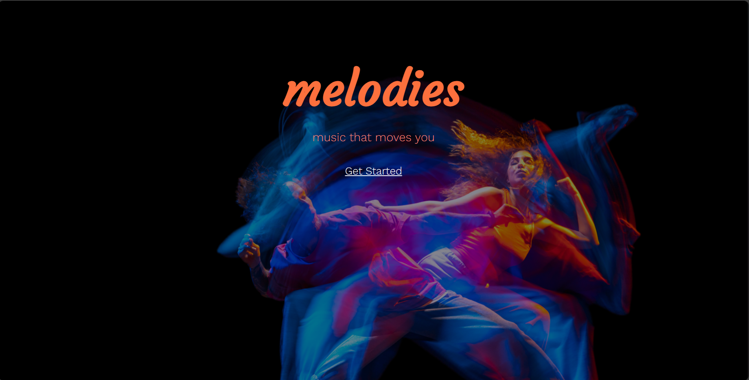

Page 2

title: “login_form1”

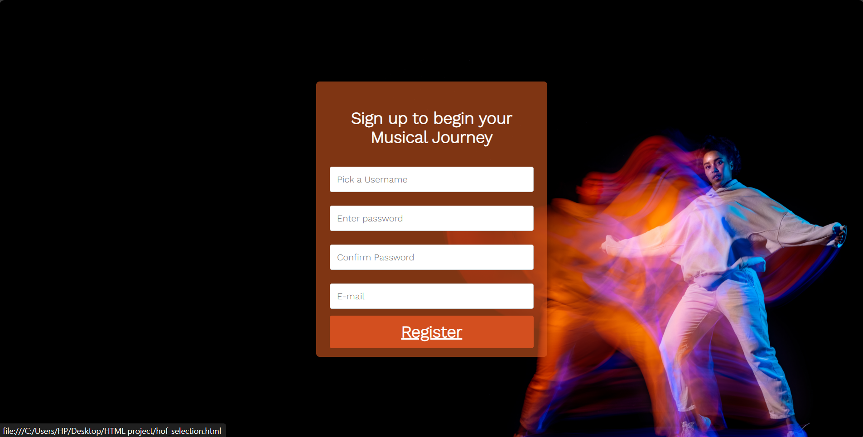

Page 3:

title: “hof_selection”

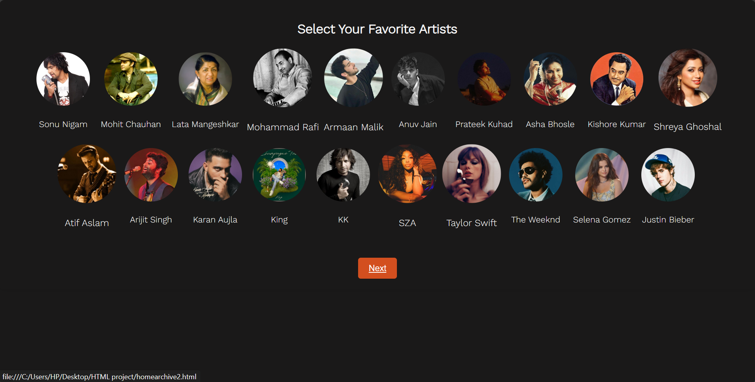

Page 4:

title: “homearchive2”, Home tab

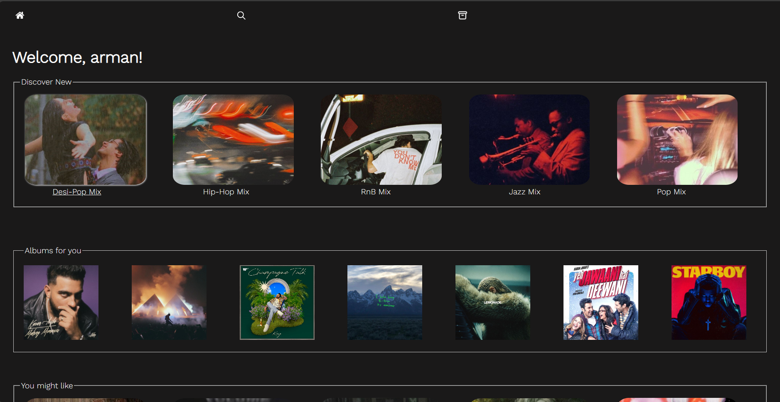

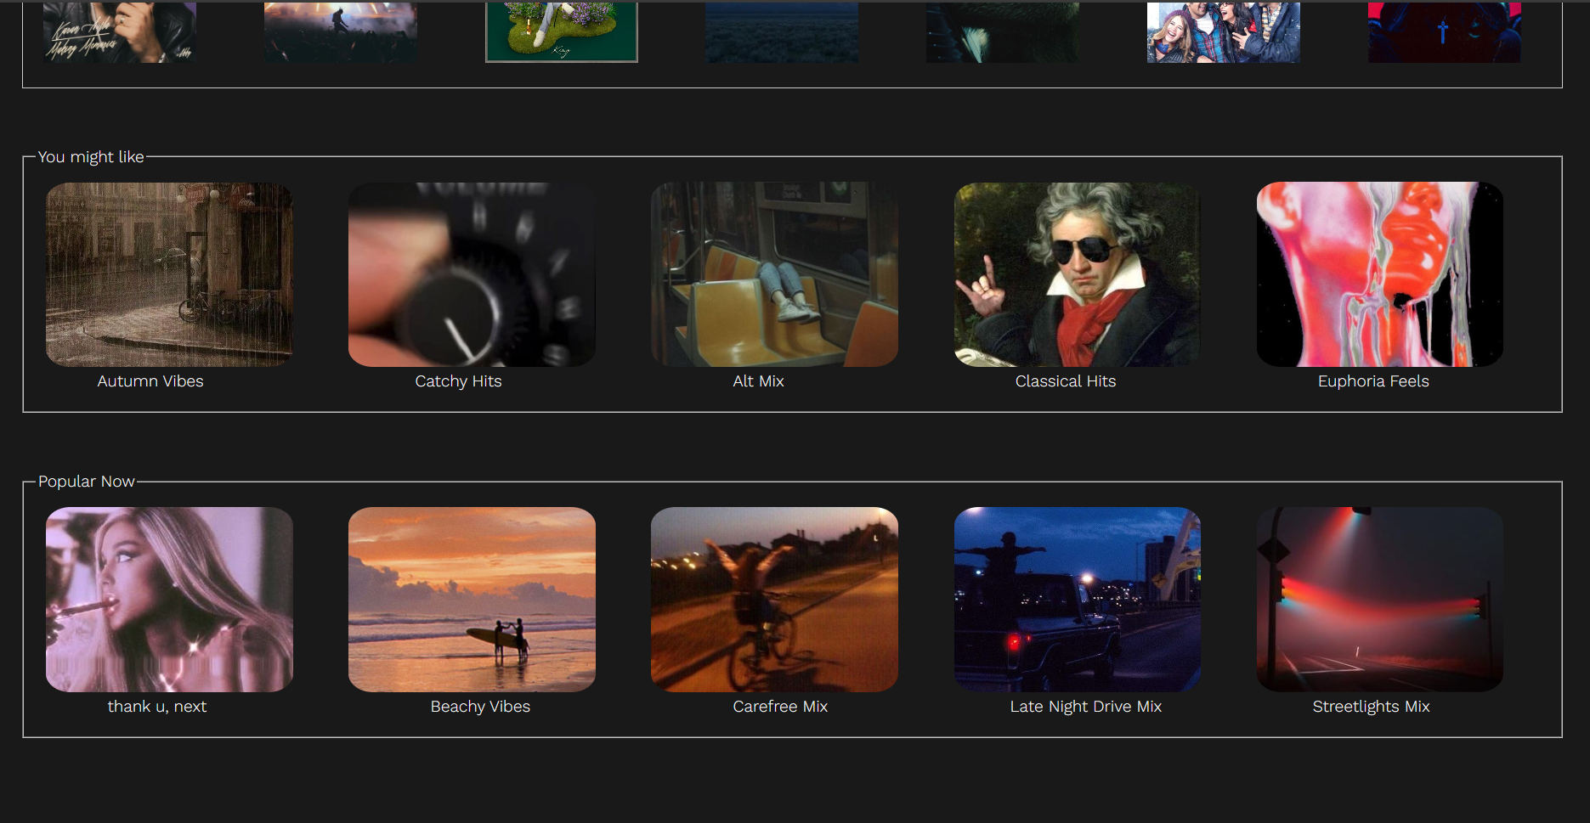

Page 5:

title: “homearcive2”, Discover tab

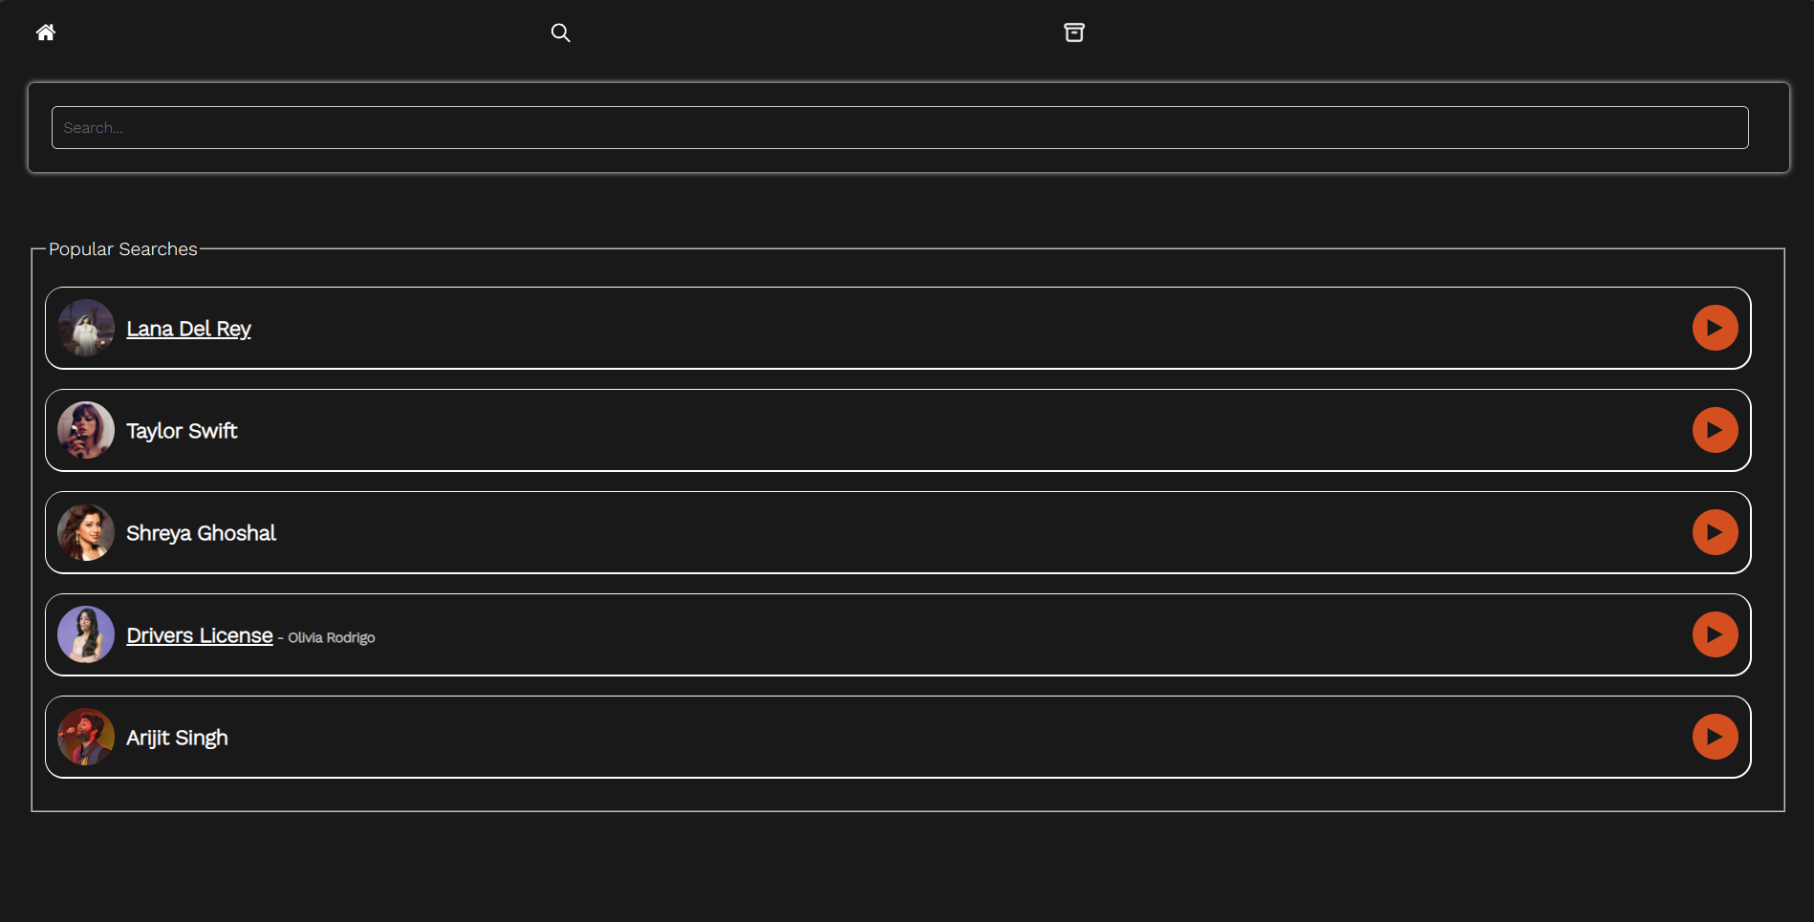

Page 6:

title: “homearchive2” Archive tab

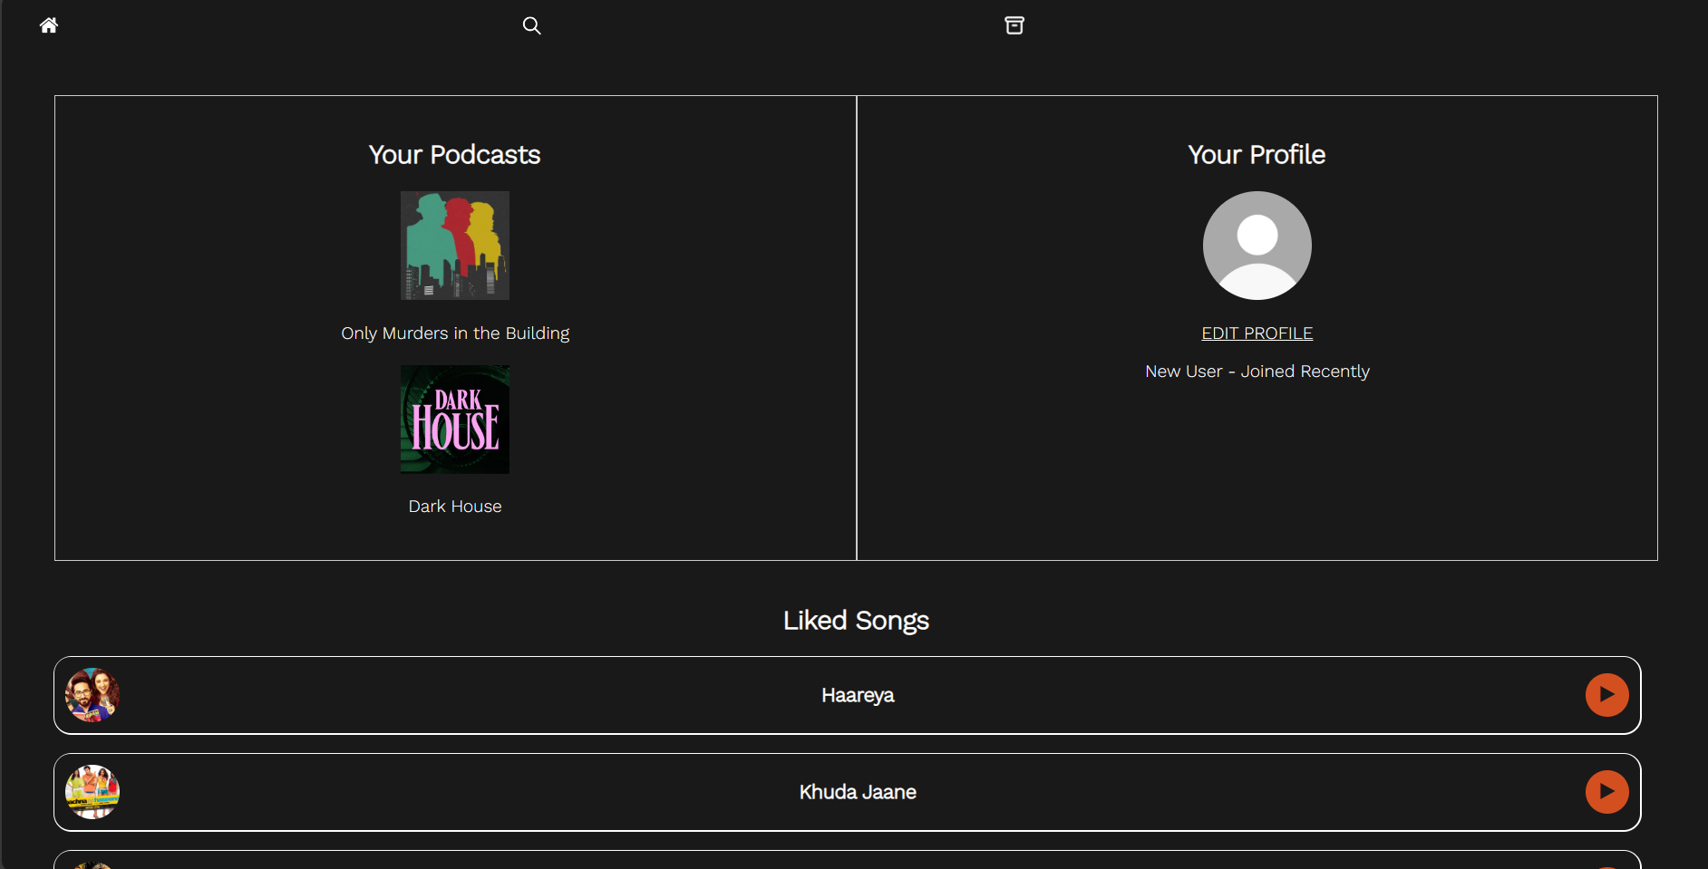

Page 7:

title: “playlist page”

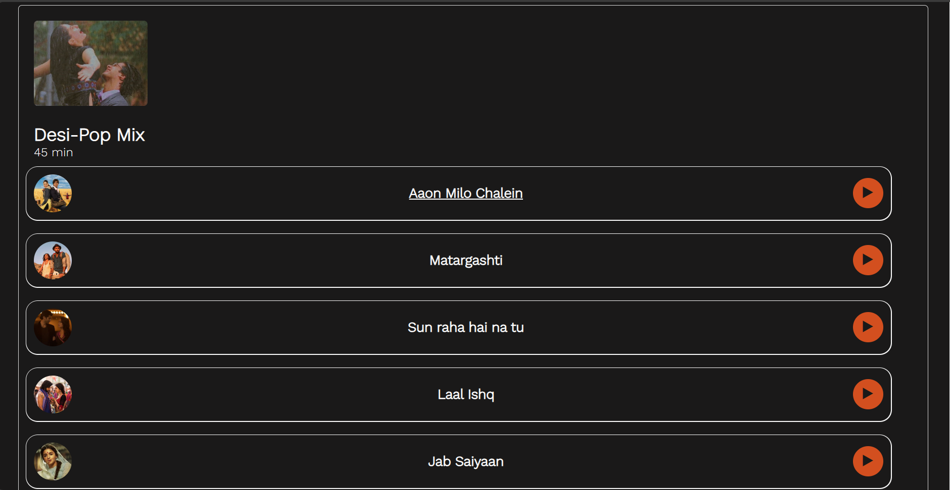

Page 8:

title: “amc”

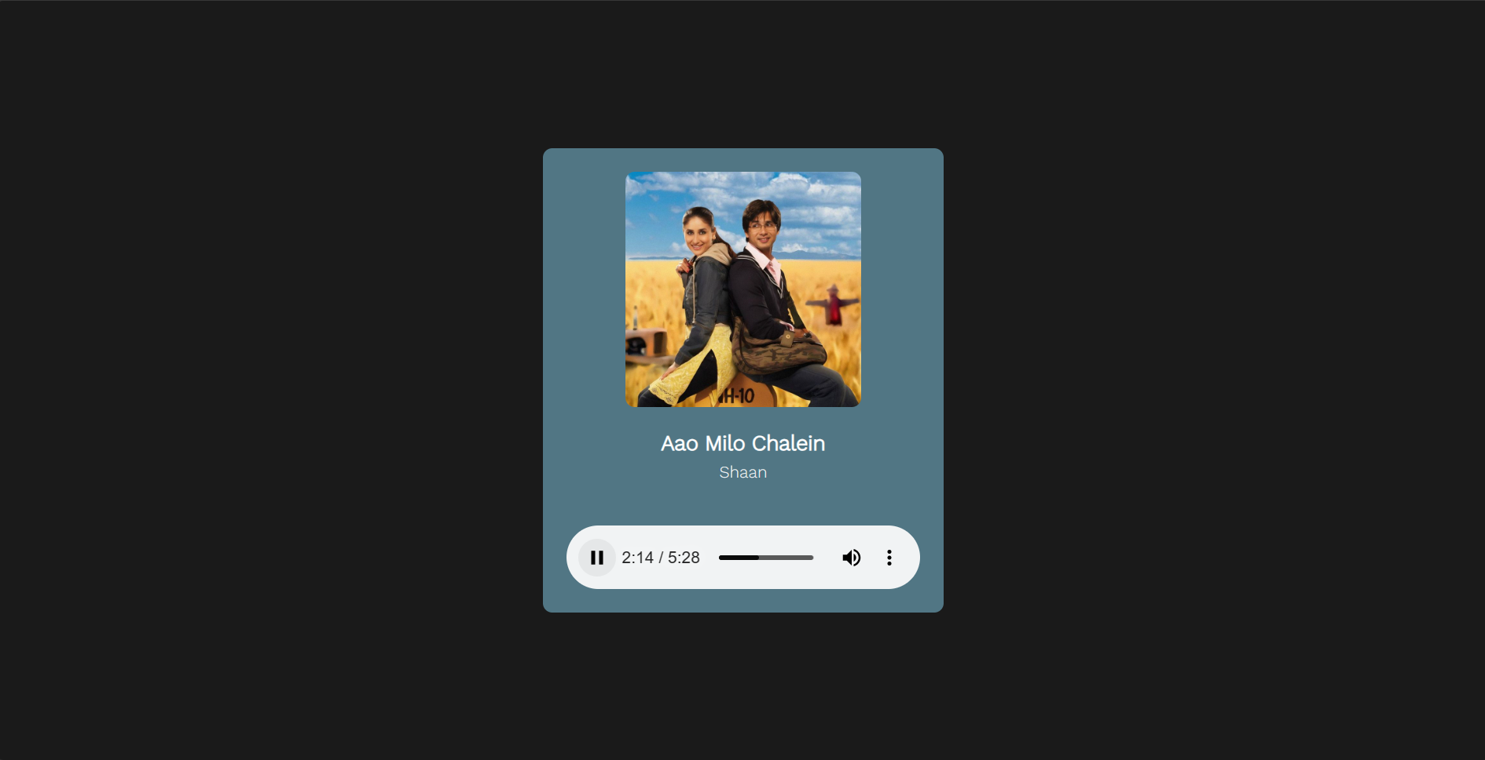

Page 9:

title: “artist_page3”

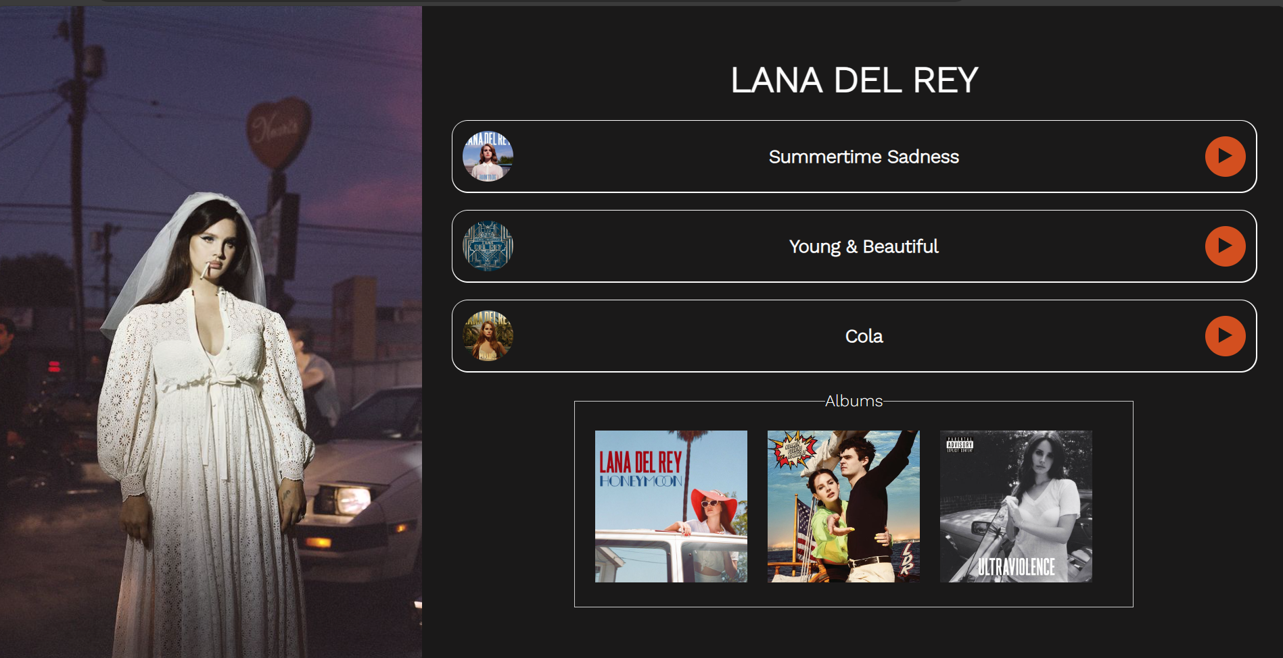

Page 10:

title: “dl”

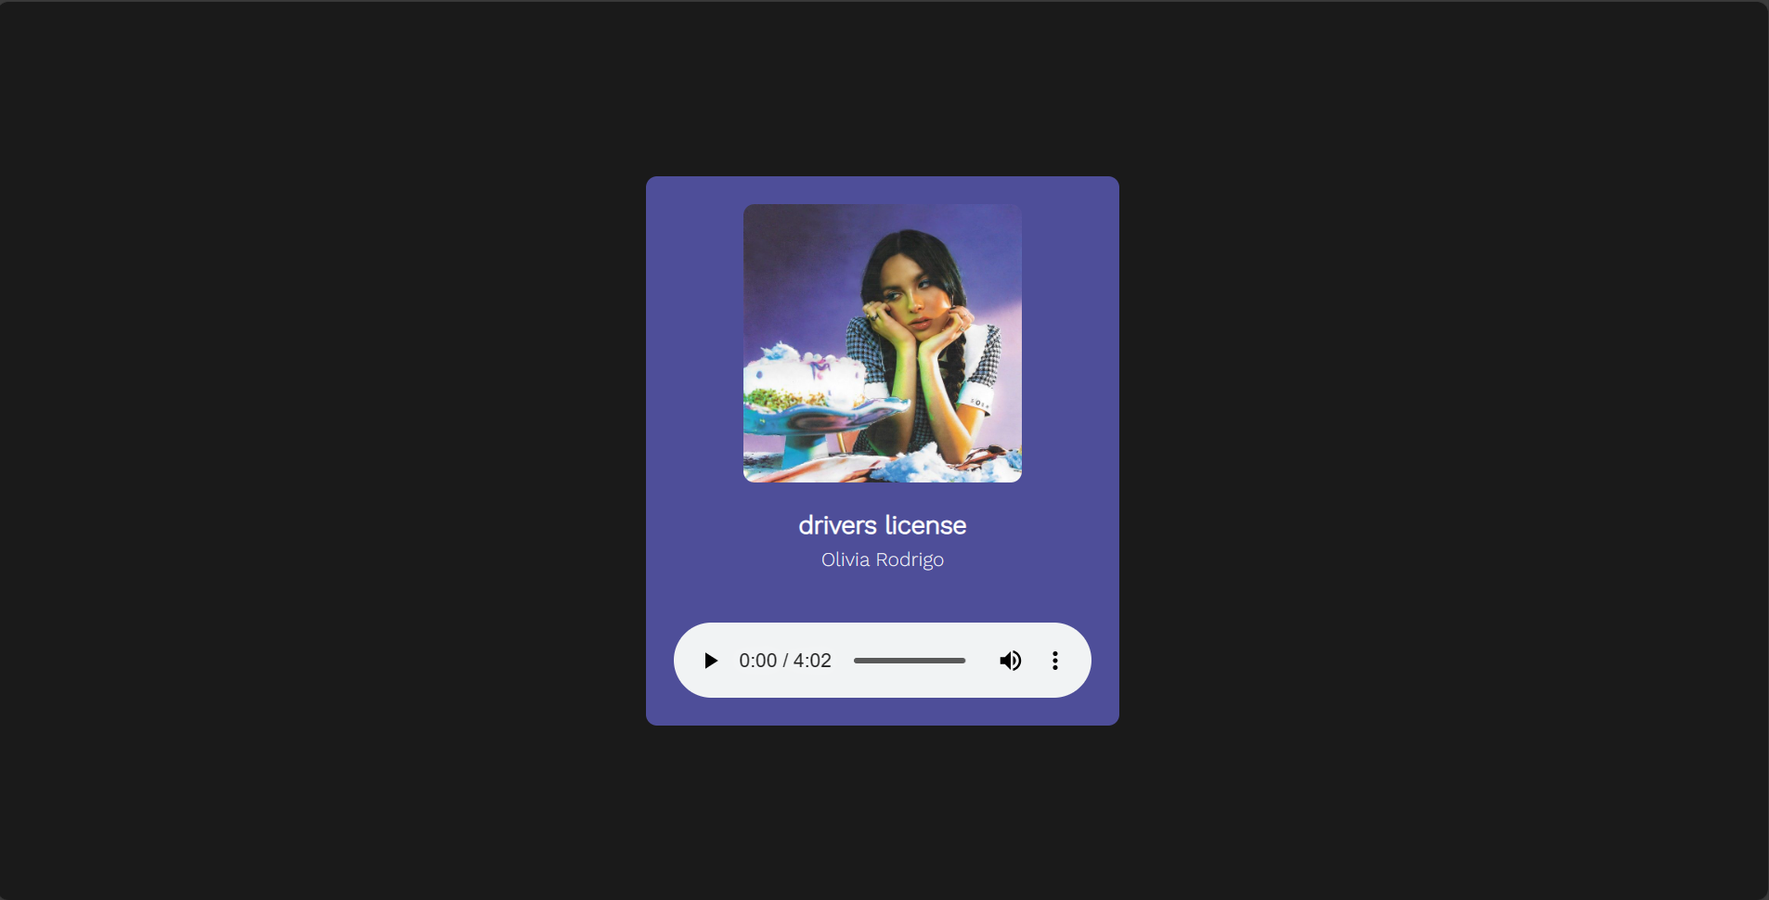

Page 11:

title: “edit12”

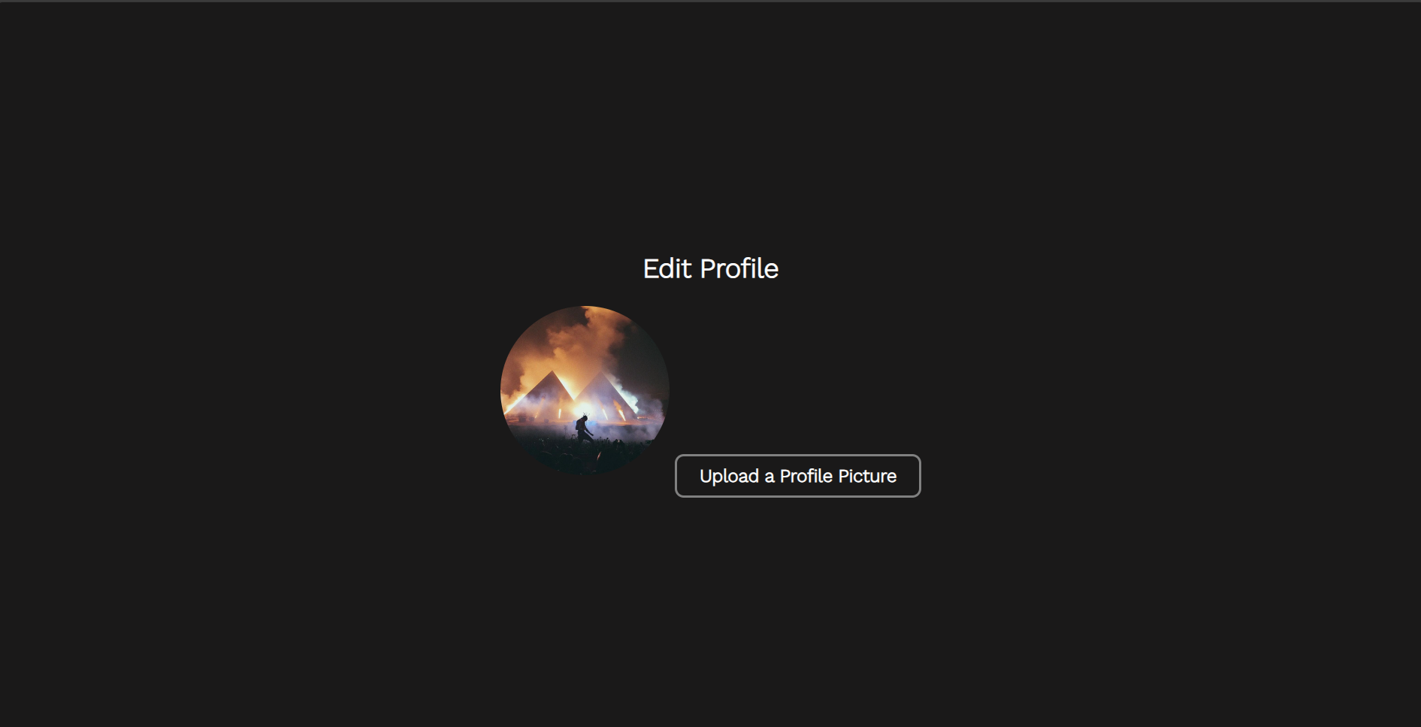

References:

1. Inspired by elements from Jio Saavn, Spotify and Apple Music.
2. Several projects on GitHub and Uizard
3. Fonts: Google Fonts (<https://fonts.googleapis.com/css2?family=Agbalumo&family=Courgette&family=Work+Sans:wght@300&display=swap>)